武汉纺织大学

Web应用开发课程设计

**基于SSM的学生选课系统**

**学 院： 数学与计算机学院**

**班 级： 软件工程11801**

**姓 名： 刘鑫**

**学 号： 1804240727**

**指导老师： 聂刚**

**成 绩：**

**完成日期： 2020年12月15日**

目 录

1 需求分析 1

1.1用户登陆 1

1.2主界面 1

1.3各项功能 1

1.3.1 登录 1

1.3.2 课程查询 1

1.3.3 选课 1

1.3.4 退选 1

1.3.5 修改密码 2

1.3.6 退出 2

1.3.7 **** 2

2 系统设计 2

2.1用户用例图 2

2.2 ER图 3

2.3 UML类图（Class Diagram） 4

2.4 UML时序图（Sequence Diagram） 5

2.4.1 系统登录 5

2.4.2 课程查询模块 5

2.4.3 修改密码模块 6

2.5活动图 6

2.5.1学生选课界面 8

2.5.2学生退课课界面 9

2.5.3课表查询界面 10

2.5.4成绩查询界面 11

2.5.5修改密码界面 12

3 系统实现 13

3.1 项目结构 13

3.2 配置文件 13

3.2.1 jdbc.properties文件 13

3.2.2 log4j.properties文件 14

3.2.3 mybatis.xml文件 14

3.3 VO类User.java 15

3.4 DAO接口类IUserDAO.java 16

3.5 接口映射文件UserMapper.xml 16

3.6 工具包Util 16

3.6.1 CreateImage 16

3.6.2 MD5Util.java 17

3.7 服务层UserService.java 17

3.8 UserServiceImpl.java 18

3.9 UserController.java 19

4 系统测试 19

5 系统总结 21

# 1 需求分析

后端采用SSM框架实现简单的学生选课系统，实现学生用户以下功能：登陆、查看所有课程、选课、退选、成绩查询统计、修改密码等。

## 1.1用户登陆

前端界面进行登录，用户名，密码和验证码

## 1.2主界面

当用户名及密码正确时，进入系统主界面，如下：

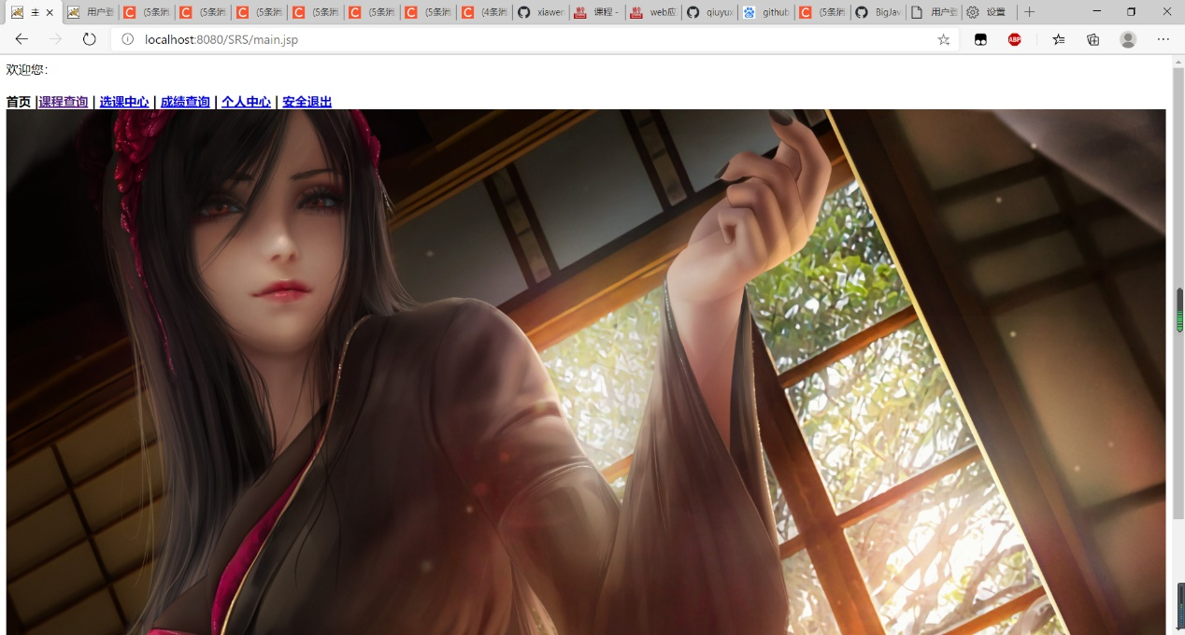

## 1.3各项功能

### 1.3.1 登录

进入系统时的登录界面，需输入正确的用户名和密码，否则无法登录，

出现错误时会显示错误信息，例如用户名不正确，密码不正确等

### 1.3.2 课程查询

直接点击课程查询，进入课程查询界面，把所有课程都展现出来

### 1.3.3 选课

当选择3时，**如果当前用户所属的角色是收银员，则显示提示信息，“当前用户没有执行该项功能的权限”**，如果当前的用户角色是管理员角色，则显示如下子菜单：

### 1.3.4 退选

当选择4时，显示“请输入当前用户的原密码：”，若原密码不正确，则提示“原密码输入不正确，请重新输入”，输入正确后，显示“请设置新的密码：”，输入的密码必须满足必要的复杂性，如果不符合要求，则提示“您的密码不符合复杂性要求（密码长度不少于6个字符，至少有一个小写字母，至少有一个大写字母，至少一个数字），请重新输入：”，输入成功后，显示“请输入确认密码：”，若两次输入不一样，则提示“两次输入的密码必须一致，请重新输入确认密码：”，输入成功后，修改数据库中的用户表，并提示“您已成功修改密码，请谨记”，返回主界面。**用户在数据库中存放时不要明文的方式进行存放，可以采用某种加密算法（如MD5加密）存放加密后的密文**。

### 1.3.5 修改密码

需要输入3个文本框，分别为旧密码，新密码和确认密码，点击确认按钮，如果修改密码失败，则会弹出错误信息，比如旧密码不正确，或者密码不一致等，修改密码成功则会回到主界面，重新选择其它功能。

### 1.3.6 退出

清除cookie和session，并自动弹出到登录界面，下次需要重新登录。

### 1.3.7 ****

每个功能按编号往后递增描述

# 2 系统设计

## 2.1用户用例图

系统分为收银员，管理员两个角色，各角色的用户用例如下图2-1所示：

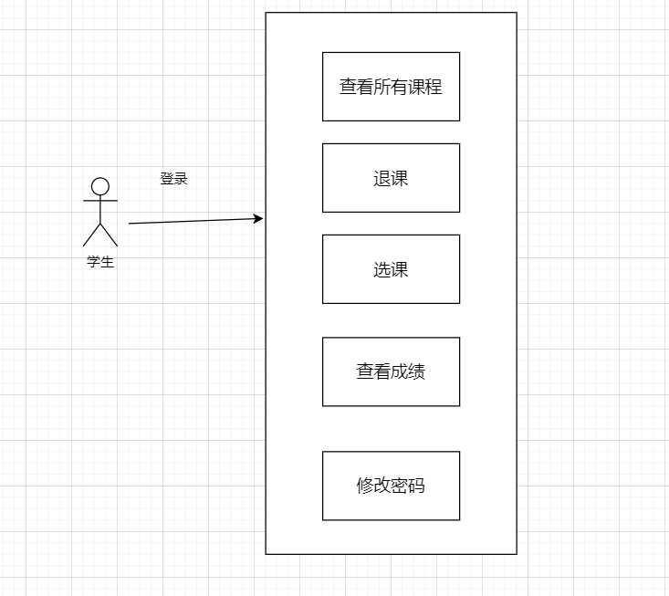

图2-1 用户用例图

## 2.2 ER图

数据库设计3张表，学生表，课程表，课程分数表，对应的ER图如图3-1所示。

%3Cmx%3D%26quot%3B16%26quot%3B%20height%3D%26quot%3B16%26quot%3B%20align%3D%26quot%3Btop%26quot%3B%26gt%3B%26amp%3Bnbsp%3B%26lt%3Bfont%20size%3D%26quot%3B1%26quot%3B%20face%3D%26quot%3BTahoma%26quot%3B%26gt%3B%26lt%3Bspan%20style%3D%26quot%3Bfont-size%3A%2013px%26quot%3B%26gt%3B%26lt%3Bb%26gt%3Bname%20varchar(10)%26lt%3B%2Fb%26gt%3B%26lt%3B%2Fspan%26gt%3B%26lt%3B%2Ffont%26gt%3B%22%20entity.column.oldName%3D%22chrName%22%20entity.column.decimals%3D%22%22%20entity.column.autoIncreament%3D%22%22%20entity.column.unsigned%3D%22%22%20entity.column.bin%3D%22%22%20entity.column.ascii%3D%22%22%20entity.column.unicode%3D%22%22%20entity.column.PK%3D%22false%22%20entity.column.unique%3D%22%22%20entity.column.isNotNull%3D%22%22%20entity.column.defaultValue%3D%22%22%20entity.column.comment%3D%22%E5%AF%86%E7%A0%81%22%20entity.column.enum%3D%22%22%20entity.column.set%3D%22%22%20entity.column.enumSetValue%3D%22%22%20id%3D%225%22%3E%3CmxCell%20style%3D%22text%3Bhtml%3D1%3BstrokeColor%3Dnone%3BfillColor%3Dnone%3BspacingLeft%3D4%3BspacingRight%3D4%3Boverflow%3Dhidden%3Brotatable%3D0%3BportConstraint%3Deastwest%3BfontSize%3D12%3BverticalAlign%3Dmiddle%3B%22%20vertex%3D%221%22%20parent%3D%222%22%3E%3CmxGeometry%20y%3D%2278%22%20width%3D%22310%22%20height%3D%2226%22%20as%3D%22geometry%22%2F%3E%3C%2FmxCell%3E%3C%2Fmysql.column%3E%3Cmysql.column%20entity.column.tableName%3D%22uses%22%20entity.column.name%3D%22role%22%20entity.column.datalen%3D%2220%22%20entity.column.dataType%3D%22VARCHAR%22%20label%3D%22%26lt%3Bimg%20title%3D%26quot%3BPrimary%20Key%26quot%3B%20src%3D%26quot%3Bimages%2Fspacer.gif%26quot%3B%20width%3D%26quot%3B16%26quot%3B%20height%3D%26quot%3B16%26quot%3B%20align%3D%26quot%3Btop%26quot%3B%26gt%3B%26amp%3Bnbsp%3B%26lt%3Bfont%20size%3D%26quot%3B1%26quot%3B%20face%3D%26quot%3BTahoma%26quot%3B%26gt%3B%26lt%3Bspan%20style%3D%26quot%3Bfont-size%3A%2013px%26quot%3B%26gt%3B%26lt%3Bb%26gt%3Bname%20varchar(10)%26lt%3B%2Fb%26gt%3B%26lt%3B%2Fspan%26gt%3B%26lt%3B%2Ffont%26gt%3B%22%20entity.column.oldName%3D%22chrName%22%20entity.column.decimals%3D%22%22%20entity.column.autoIncreament%3D%22%22%20entity.column.unsigned%3D%22%22%20entity.column.bin%3D%22%22%20entity.column.ascii%3D%22%22%20entity.column.unicode%3D%22%22%20entity.column.PK%3D%22false%22%20entity.column.unique%3D%22%22%20entity.column.isNotNull%3D%22%22%20entity.column.defaultValue%3D%22%22%20entity.column.comment%3D%22%E8%A7%92%E8%89%B2%22%20entity.column.enum%3D%22%22%20entity.column.set%3D%22%22%20entity.column.enumSetValue%3D%22%22%20id%3D%226%22%3E%3CmxCell%20style%3D%22text%3Bhtml%3D1%3BstrokeColor%3Dnone%3BfillColor%3Dnone%3BspacingLeft%3D4%3BspacingRight%3D4%3Boverflow%3Dhidden%3Brotatable%3D0%3BportConstraint%3Deastwest%3BfontSize%3D12%3BverticalAlign%3Dmiddle%3B%22%20vertex%3D%221%22%20parent%3D%222%22%3E%3CmxGeometry%20y%3D%22104%22%20width%3D%22310%22%20height%3D%2226%22%20as%3D%22geometry%22%2F%3E%3C%2FmxCell%3E%3C%2Fmysql.column%3E%3Cmysql.table%20entity.table.tableName%3D%22product%22%20label%3D%22product%22%20id%3D%227%22%3E%3CmxCell%20style%3D%22swimlane%3BfontStyle%3D0%3BchildLayout%3DstackLayout%3Bhorizontal%3D1%3Bhtml%3D1%3BstartSize%3D26%3BfillColor%3D%23b0e3e6%3BhorizontalStack%3D0%3BresizeParent%3D1%3BresizeParentMax%3D0%3BresizeLast%3D0%3Bcollapsible%3D1%3BmarginBottom%3D0%3BswimlaneFillColor%3D%23ffffff%3Balign%3Dcenter%3BfontSize%3D13%3BstrokeColor%3D%230e8088%3Brounded%3D0%3Bshadow%3D1%3Bcomic%3D0%3Bglass%3D0%3BgradientDirection%3Dsouth%3BgradientColor%3D%23ffffff%3B%22%20vertex%3D%221%22%20connectable%3D%220%22%20parent%3D%221%22%3E%3CmxGeometry%20x%3D%2260%22%20y%3D%22210%22%20width%3D%22310%22%20height%3D%22130%22%20as%3D%22geometry%22%2F%3E%3C%2FmxCell%3E%3C%2Fmysql.table%3E%3Cmysql.column%20entity.column.tableName%3D%22product%22%20entity.column.name%3D%22barcode%22%20entity.column.dataType%3D%22VARCHAR%22%20entity.column.PK%3D%22true%22%20label%3D%22%26lt%3Bimg%20title%3D%26quot%3BPrimary%20Key%26quot%3B%20src%3D%26quot%3Bimg%2Fdb%2Fkey1.png%26quot%3B%20width%3D%26quot%3B16%26quot%3B%20height%3D%26quot%3B16%26quot%3B%20align%3D%26quot%3Btop%26quot%3B%26gt%3B%26amp%3Bnbsp%3B%26lt%3Bfont%20size%3D%26quot%3B1%26quot%3B%20face%3D%26quot%3BTahoma%26quot%3B%26gt%3B%26lt%3Bspan%20style%3D%26quot%3Bfont-size%3A%2013px%26quot%3B%26gt%3B%26lt%3Bb%26gt%3Bid%20int%20primary%20key%26lt%3B%2Fb%26gt%3B%26lt%3B%2Fspan%26gt%3B%26lt%3B%2Ffont%26gt%3B%22%20entity.column.oldName%3D%22id%22%20entity.column.datalen%3D%2210%22%20entity.column.decimals%3D%22%22%20entity.column.autoIncreament%3D%22%22%20entity.column.unsigned%3D%22%22%20entity.column.bin%3D%22%22%20entity.column.ascii%3D%22%22%20entity.column.unicode%3D%22%22%20entity.column.unique%3D%22%22%20entity.column.isNotNull%3D%22NOT%20NULL%22%20entity.column.defaultValue%3D%22%22%20entity.column.comment%3D%22%22%20entity.column.enum%3D%22%22%20entity.column.set%3D%22%22%20entity.column.enumSetValue%3D%22%22%20id%3D%228%22%3E%3CmxCell%20style%3D%22text%3Bhtml%3D1%3BstrokeColor%3Dnone%3BfillColor%3Dnone%3BspacingLeft%3D4%3BspacingRight%3D4%3Boverflow%3Dhidden%3Brotatable%3D0%3BportConstraint%3Deastwest%3BfontSize%3D12%3BverticalAlign%3Dmiddle%3B%22%20vertex%3D%221%22%20parent%3D%227%22%3E%3CmxGeometry%20y%3D%2226%22%20width%3D%22310%22%20height%3D%2226%22%20as%3D%22geometry%22%2F%3E%3C%2FmxCell%3E%3C%2Fmysql.column%3E%3Cmysql.column%20entity.column.tableName%3D%22product%22%20entity.column.name%3D%22productName%22%20entity.column.datalen%3D%2250%22%20entity.column.dataType%3D%22VARCHAR%22%20label%3D%22%26lt%3Bimg%20title%3D%26quot%3BPrimary%20Key%26quot%3B%20src%3D%26quot%3Bimages%2Fspacer.gif%26quot%3B%20width%3D%26quot%3B16%26quot%3B%20height%3D%26quot%3B16%26quot%3B%20align%3D%26quot%3Btop%26quot%3B%26gt%3B%26amp%3Bnbsp%3B%26lt%3Bfont%20size%3D%26quot%3B1%26quot%3B%20face%3D%26quot%3BTahoma%26quot%3B%26gt%3B%26lt%3Bspan%20style%3D%26quot%3Bfont-size%3A%2013px%26quot%3B%26gt%3B%26lt%3Bb%26gt%3Bname%20varchar(10)%26lt%3B%2Fb%26gt%3B%26lt%3B%2Fspan%26gt%3B%26lt%3B%2Ffont%26gt%3B%22%20entity.column.oldName%3D%22name%22%20entity.column.decimals%3D%22%22%20entity.column.autoIncreament%3D%22%22%20entity.column.unsigned%3D%22%22%20entity.column.bin%3D%22%22%20entity.column.ascii%3D%22%22%20entity.column.unicode%3D%22%22%20entity.column.PK%3D%22false%22%20entity.column.unique%3D%22%22%20entity.column.isNotNull%3D%22%22%20entity.column.defaultValue%3D%22%22%20entity.column.comment%3D%22%22%20entity.column.enum%3D%22%22%20entity.column.set%3D%22%22%20entity.column.enumSetValue%3D%22%22%20id%3D%229%22%3E%3CmxCell%20style%3D%22text%3Bhtml%3D1%3BstrokeColor%3Dnone%3BfillColor%3Dnone%3BspacingLeft%3D4%3BspacingRight%3D4%3Boverflow%3Dhidden%3Brotatable%3D0%3BportConstraint%3Deastwest%3BfontSize%3D12%3BverticalAlign%3Dmiddle%3B%22%20vertex%3D%221%22%20parent%3D%227%22%3E%3CmxGeometry%20y%3D%2252%22%20width%3D%22310%22%20height%3D%2226%22%20as%3D%22geometry%22%2F%3E%3C%2FmxCell%3E%3C%2Fmysql.column%3E%3Cmysql.column%20entity.column.tableName%3D%22product%22%20entity.column.name%3D%22price%22%20entity.column.datalen%3D%229%22%20entity.column.dataType%3D%22DECIMAL%22%20label%3D%22%26lt%3Bimg%20title%3D%26quot%3BPrimary%20Key%26quot%3B%20src%3D%26quot%3Bimages%2Fspacer.gif%26quot%3B%20width%3D%26quot%3B16%26quot%3B%20height%3D%26quot%3B16%26quot%3B%20align%3D%26quot%3Btop%26quot%3B%26gt%3B%26amp%3Bnbsp%3B%26lt%3Bfont%20size%3D%26quot%3B1%26quot%3B%20face%3D%26quot%3BTahoma%26quot%3B%26gt%3B%26lt%3Bspan%20style%3D%26quot%3Bfont-size%3A%2013px%26quot%3B%26gt%3B%26lt%3Bb%26gt%3Bname%20varchar(10)%26lt%3B%2Fb%26gt%3B%26lt%3B%2Fspan%26gt%3B%26lt%3B%2Ffont%26gt%3B%22%20entity.column.oldName%3D%22price%22%20entity.column.decimals%3D%222%22%20entity.column.autoIncreament%3D%22%22%20entity.column.unsigned%3D%22%22%20entity.column.bin%3D%22%22%20entity.column.ascii%3D%22%22%20entity.column.unicode%3D%22%22%20entity.column.PK%3D%22false%22%20entity.column.unique%3D%22%22%20entity.column.isNotNull%3D%22%22%20entity.column.defaultValue%3D%22%22%20entity.column.comment%3D%22%22%20entity.column.enum%3D%22%22%20entity.column.set%3D%22%22%20entity.column.enumSetValue%3D%22%22%20id%3D%2210%22%3E%3CmxCell%20style%3D%22text%3Bhtml%3D1%3BstrokeColor%3Dnone%3BfillColor%3Dnone%3BspacingLeft%3D4%3BspacingRight%3D4%3Boverflow%3Dhidden%3Brotatable%3D0%3BportConstraint%3Deastwest%3BfontSize%3D12%3BverticalAlign%3Dmiddle%3B%22%20vertex%3D%221%22%20parent%3D%227%22%3E%3CmxGeometry%20y%3D%2278%22%20width%3D%22310%22%20height%3D%2226%22%20as%3D%22geometry%22%2F%3E%3C%2FmxCell%3E%3C%2Fmysql.column%3E%3Cmysql.column%20entity.column.tableName%3D%22product%22%20entity.column.name%3D%22supply%22%20entity.column.datalen%3D%2220%22%20entity.column.dataType%3D%22VARCHAR%22%20label%3D%22%26lt%3Bimg%20title%3D%26quot%3BPrimary%20Key%26quot%3B%20src%3D%26quot%3Bimages%2Fspacer.gif%26quot%3B%20width%3D%26quot%3B16%26quot%3B%20height%3D%26quot%3B16%26quot%3B%20align%3D%26quot%3Btop%26quot%3B%26gt%3B%26amp%3Bnbsp%3B%26lt%3Bfont%20size%3D%26quot%3B1%26quot%3B%20face%3D%26quot%3BTahoma%26quot%3B%26gt%3B%26lt%3Bspan%20style%3D%26quot%3Bfont-size%3A%2013px%26quot%3B%26gt%3B%26lt%3Bb%26gt%3Bname%20varchar(10)%26lt%3B%2Fb%26gt%3B%26lt%3B%2Fspan%26gt%3B%26lt%3B%2Ffont%26gt%3B%22%20entity.column.oldName%3D%22price%22%20entity.column.decimals%3D%22%22%20entity.column.autoIncreament%3D%22%22%20entity.column.unsigned%3D%22%22%20entity.column.bin%3D%22%22%20entity.column.ascii%3D%22%22%20entity.column.unicode%3D%22%22%20entity.column.PK%3D%22false%22%20entity.column.unique%3D%22%22%20entity.column.isNotNull%3D%22%22%20entity.column.defaultValue%3D%22%22%20entity.column.comment%3D%22%22%20entity.column.enum%3D%22%22%20entity.column.set%3D%22%22%20entity.column.enumSetValue%3D%22%22%20id%3D%2211%22%3E%3CmxCell%20style%3D%22text%3Bhtml%3D1%3BstrokeColor%3Dnone%3BfillColor%3Dnone%3BspacingLeft%3D4%3BspacingRight%3D4%3Boverflow%3Dhidden%3Brotatable%3D0%3BportConstraint%3Deastwest%3BfontSize%3D12%3BverticalAlign%3Dmiddle%3B%22%20vertex%3D%221%22%20parent%3D%227%22%3E%3CmxGeometry%20y%3D%22104%22%20width%3D%22310%22%20height%3D%2226%22%20as%3D%22geometry%22%2F%3E%3C%2FmxCell%3E%3C%2Fmysql.column%3E%3Cmysql.table%20entity.table.tableName%3D%22saleDetail%22%20label%3D%22saleDetail%22%20id%3D%2212%22%3E%3CmxCell%20style%3D%22swimlane%3BfontStyle%3D0%3BchildLayout%3DstackLayout%3Bhorizontal%3D1%3Bhtml%3D1%3BstartSize%3D26%3BfillColor%3D%23b0e3e6%3BhorizontalStack%3D0%3BresizeParent%3D1%3BresizeParentMax%3D0%3BresizeLast%3D0%3Bcollapsible%3D1%3BmarginBottom%3D0%3BswimlaneFillColor%3D%23ffffff%3Balign%3Dcenter%3BfontSize%3D13%3BstrokeColor%3D%230e8088%3Brounded%3D0%3Bshadow%3D1%3Bcomic%3D0%3Bglass%3D0%3BgradientDirection%3Dsouth%3BgradientColor%3D%23ffffff%3B%22%20vertex%3D%221%22%20connectable%3D%220%22%20parent%3D%221%22%3E%3CmxGeometry%20x%3D%22480%22%20y%3D%2280%22%20width%3D%22280%22%20height%3D%22208%22%20as%3D%22geometry%22%2F%3E%3C%2FmxCell%3E%3C%2Fmysql.table%3E%3Cmysql.column%20entity.column.tableName%3D%22saleDetail%22%20entity.column.name%3D%22lsh%22%20entity.column.dataType%3D%22VARCHAR%22%20entity.column.PK%3D%22true%22%20label%3D%22%26lt%3Bimg%20title%3D%26quot%3BPrimary%20Key%26quot%3B%20src%3D%26quot%3Bimg%2Fdb%2Fkey1.png%26quot%3B%20width%3D%26quot%3B16%26quot%3B%20height%3D%26quot%3B16%26quot%3B%20align%3D%26quot%3Btop%26quot%3B%26gt%3B%26amp%3Bnbsp%3B%26lt%3Bfont%20size%3D%26quot%3B1%26quot%3B%20face%3D%26quot%3BTahoma%26quot%3B%26gt%3B%26lt%3Bspan%20style%3D%26quot%3Bfont-size%3A%2013px%26quot%3B%26gt%3B%26lt%3Bb%26gt%3Bid%20int%20primary%20key%26lt%3B%2Fb%26gt%3B%26lt%3B%2Fspan%26gt%3B%26lt%3B%2Ffont%26gt%3B%22%20entity.column.oldName%3D%22id%22%20entity.column.datalen%3D%2220%22%20entity.column.decimals%3D%22%22%20entity.column.autoIncreament%3D%22%22%20entity.column.unsigned%3D%22%22%20entity.column.bin%3D%22%22%20entity.column.ascii%3D%22%22%20entity.column.unicode%3D%22%22%20entity.column.unique%3D%22%22%20entity.column.isNotNull%3D%22NOT%20NULL%22%20entity.column.defaultValue%3D%22%22%20entity.column.comment%3D%22%22%20entity.column.enum%3D%22%22%20entity.column.set%3D%22%22%20entity.column.enumSetValue%3D%22%22%20id%3D%2213%22%3E%3CmxCell%20style%3D%22text%3Bhtml%3D1%3BstrokeColor%3Dnone%3BfillColor%3Dnone%3BspacingLeft%3D4%3BspacingRight%3D4%3Boverflow%3Dhidden%3Brotatable%3D0%3BportConstraint%3Deastwest%3BfontSize%3D12%3BverticalAlign%3Dmiddle%3B%22%20vertex%3D%221%22%20parent%3D%2212%22%3E%3CmxGeometry%20y%3D%2226%22%20width%3D%22280%22%20height%3D%2226%22%20as%3D%22geometry%22%2F%3E%3C%2FmxCell%3E%3C%2Fmysql.column%3E%3Cmysql.column%20entity.column.tableName%3D%22saleDetail%22%20entity.column.name%3D%22barcode%22%20entity.column.datalen%3D%2210%22%20entity.column.dataType%3D%22VARCHAR%22%20label%3D%22%26lt%3Bimg%20title%3D%26quot%3BPrimary%20Key%26quot%3B%20src%3D%26quot%3Bimages%2Fspacer.gif%26quot%3B%20width%3D%26quot%3B16%26quot%3B%20height%3D%26quot%3B16%26quot%3B%20align%3D%26quot%3Btop%26quot%3B%26gt%3B%26amp%3Bnbsp%3B%26lt%3Bfont%20size%3D%26quot%3B1%26quot%3B%20face%3D%26quot%3BTahoma%26quot%3B%26gt%3B%26lt%3Bspan%20style%3D%26quot%3Bfont-size%3A%2013px%26quot%3B%26gt%3B%26lt%3Bb%26gt%3Bname%20varchar(10)%26lt%3B%2Fb%26gt%3B%26lt%3B%2Fspan%26gt%3B%26lt%3B%2Ffont%26gt%3B%22%20entity.column.oldName%3D%22barcode%22%20entity.column.decimals%3D%22%22%20entity.column.autoIncreament%3D%22%22%20entity.column.unsigned%3D%22%22%20entity.column.bin%3D%22%22%20entity.column.ascii%3D%22%22%20entity.column.unicode%3D%22%22%20entity.column.PK%3D%22false%22%20entity.column.unique%3D%22%22%20entity.column.isNotNull%3D%22%22%20entity.column.defaultValue%3D%22%22%20entity.column.comment%3D%22%22%20entity.column.enum%3D%22%22%20entity.column.set%3D%22%22%20entity.column.enumSetValue%3D%22%22%20id%3D%2214%22%3E%3CmxCell%20style%3D%22text%3Bhtml%3D1%3BstrokeColor%3Dnone%3BfillColor%3Dnone%3BspacingLeft%3D4%3BspacingRight%3D4%3Boverflow%3Dhidden%3Brotatable%3D0%3BportConstraint%3Deastwest%3BfontSize%3D12%3BverticalAlign%3Dmiddle%3B%22%20vertex%3D%221%22%20parent%3D%2212%22%3E%3CmxGeometry%20y%3D%2252%22%20width%3D%22280%22%20height%3D%2226%22%20as%3D%22geometry%22%2F%3E%3C%2FmxCell%3E%3C%2Fmysql.column%3E%3Cmysql.column%20entity.column.tableName%3D%22saleDetail%22%20entity.column.name%3D%22productName%22%20entity.column.datalen%3D%2250%22%20entity.column.dataType%3D%22VARCHAR%22%20label%3D%22%26lt%3Bimg%20title%3D%26quot%3BPrimary%20Key%26quot%3B%20src%3D%26quot%3Bimages%2Fspacer.gif%26quot%3B%20width%3D%26quot%3B16%26quot%3B%20height%3D%26quot%3B16%26quot%3B%20align%3D%26quot%3Btop%26quot%3B%26gt%3B%26amp%3Bnbsp%3B%26lt%3Bfont%20size%3D%26quot%3B1%26quot%3B%20face%3D%26quot%3BTahoma%26quot%3B%26gt%3B%26lt%3Bspan%20style%3D%26quot%3Bfont-size%3A%2013px%26quot%3B%26gt%3B%26lt%3Bb%26gt%3Bname%20varchar(10)%26lt%3B%2Fb%26gt%3B%26lt%3B%2Fspan%26gt%3B%26lt%3B%2Ffont%26gt%3B%22%20entity.column.oldName%3D%22productName%22%20entity.column.decimals%3D%22%22%20entity.column.autoIncreament%3D%22%22%20entity.column.unsigned%3D%22%22%20entity.column.bin%3D%22%22%20entity.column.ascii%3D%22%22%20entity.column.unicode%3D%22%22%20entity.column.PK%3D%22false%22%20entity.column.unique%3D%22%22%20entity.column.isNotNull%3D%22%22%20entity.column.defaultValue%3D%22%22%20entity.column.comment%3D%22%22%20entity.column.enum%3D%22%22%20entity.column.set%3D%22%22%20entity.column.enumSetValue%3D%22%22%20id%3D%2215%22%3E%3CmxCell%20style%3D%22text%3Bhtml%3D1%3BstrokeColor%3Dnone%3BfillColor%3Dnone%3BspacingLeft%3D4%3BspacingRight%3D4%3Boverflow%3Dhidden%3Brotatable%3D0%3BportConstraint%3Deastwest%3BfontSize%3D12%3BverticalAlign%3Dmiddle%3B%22%20vertex%3D%221%22%20parent%3D%2212%22%3E%3CmxGeometry%20y%3D%2278%22%20width%3D%22280%22%20height%3D%2226%22%20as%3D%22geometry%22%2F%3E%3C%2FmxCell%3E%3C%2Fmysql.column%3E%3Cmysql.column%20entity.column.tableName%3D%22saleDetail%22%20entity.column.name%3D%22price%22%20entity.column.datalen%3D%229%22%20entity.column.dataType%3D%22DECIMAL%22%20label%3D%22%26lt%3Bimg%20title%3D%26quot%3BPrimary%20Key%26quot%3B%20src%3D%26quot%3Bimages%2Fspacer.gif%26quot%3B%20width%3D%26quot%3B16%26quot%3B%20height%3D%26quot%3B16%26quot%3B%20align%3D%26quot%3Btop%26quot%3B%26gt%3B%26amp%3Bnbsp%3B%26lt%3Bfont%20size%3D%26quot%3B1%26quot%3B%20face%3D%26quot%3BTahoma%26quot%3B%26gt%3B%26lt%3Bspan%20style%3D%26quot%3Bfont-size%3A%2013px%26quot%3B%26gt%3B%26lt%3Bb%26gt%3Bname%20varchar(10)%26lt%3B%2Fb%26gt%3B%26lt%3B%2Fspan%26gt%3B%26lt%3B%2Ffont%26gt%3B%22%20entity.column.oldName%3D%22productName%22%20entity.column.decimals%3D%222%22%20entity.column.autoIncreament%3D%22%22%20entity.column.unsigned%3D%22%22%20entity.column.bin%3D%22%22%20entity.column.ascii%3D%22%22%20entity.column.unicode%3D%22%22%20entity.column.PK%3D%22false%22%20entity.column.unique%3D%22%22%20entity.column.isNotNull%3D%22%22%20entity.column.defaultValue%3D%22%22%20entity.column.comment%3D%22%22%20entity.column.enum%3D%22%22%20entity.column.set%3D%22%22%20entity.column.enumSetValue%3D%22%22%20id%3D%2216%22%3E%3CmxCell%20style%3D%22text%3Bhtml%3D1%3BstrokeColor%3Dnone%3BfillColor%3Dnone%3BspacingLeft%3D4%3BspacingRight%3D4%3Boverflow%3Dhidden%3Brotatable%3D0%3BportConstraint%3Deastwest%3BfontSize%3D12%3BverticalAlign%3Dmiddle%3B%22%20vertex%3D%221%22%20parent%3D%2212%22%3E%3CmxGeometry%20y%3D%22104%22%20width%3D%22280%22%20height%3D%2226%22%20as%3D%22geometry%22%2F%3E%3C%2FmxCell%3E%3C%2Fmysql.column%3E%3Cmysql.column%20entity.column.tableName%3D%22saleDetail%22%20entity.column.name%3D%22count%22%20entity.column.datalen%3D%229%22%20entity.column.dataType%3D%22INT%22%20label%3D%22%26lt%3Bimg%20title%3D%26quot%3BPrimary%20Key%26quot%3B%20src%3D%26quot%3Bimages%2Fspacer.gif%26quot%3B%20width%3D%26quot%3B16%26quot%3B%20height%3D%26quot%3B16%26quot%3B%20align%3D%26quot%3Btop%26quot%3B%26gt%3B%26amp%3Bnbsp%3B%26lt%3Bfont%20size%3D%26quot%3B1%26quot%3B%20face%3D%26quot%3BTahoma%26quot%3B%26gt%3B%26lt%3Bspan%20style%3D%26quot%3Bfont-size%3A%2013px%26quot%3B%26gt%3B%26lt%3Bb%26gt%3Bname%20varchar(10)%26lt%3B%2Fb%26gt%3B%26lt%3B%2Fspan%26gt%3B%26lt%3B%2Ffont%26gt%3B%22%20entity.column.oldName%3D%22price%22%20entity.column.decimals%3D%22%22%20entity.column.autoIncreament%3D%22%22%20entity.column.unsigned%3D%22%22%20entity.column.bin%3D%22%22%20entity.column.ascii%3D%22%22%20entity.column.unicode%3D%22%22%20entity.column.PK%3D%22false%22%20entity.column.unique%3D%22%22%20entity.column.isNotNull%3D%22%22%20entity.column.defaultValue%3D%22%22%20entity.column.comment%3D%22%22%20entity.column.enum%3D%22%22%20entity.column.set%3D%22%22%20entity.column.enumSetValue%3D%22%22%20id%3D%2217%22%3E%3CmxCell%20style%3D%22text%3Bhtml%3D1%3BstrokeColor%3Dnone%3BfillColor%3Dnone%3BspacingLeft%3D4%3BspacingRight%3D4%3Boverflow%3Dhidden%3Brotatable%3D0%3BportConstraint%3Deastwest%3BfontSize%3D12%3BverticalAlign%3Dmiddle%3B%22%20vertex%3D%221%22%20parent%3D%2212%22%3E%3CmxGeometry%20y%3D%22130%22%20width%3D%22280%22%20height%3D%2226%22%20as%3D%22geometry%22%2F%3E%3C%2FmxCell%3E%3C%2Fmysql.column%3E%3Cmysql.column%20entity.column.tableName%3D%22saleDetail%22%20entity.column.name%3D%22operator%22%20entity.column.datalen%3D%2220%22%20entity.column.dataType%3D%22VARCHAR%22%20label%3D%22%26lt%3Bimg%20title%3D%26quot%3BPrimary%20Key%26quot%3B%20src%3D%26quot%3Bimages%2Fspacer.gif%26quot%3B%20width%3D%26quot%3B16%26quot%3B%20height%3D%26quot%3B16%26quot%3B%20align%3D%26quot%3Btop%26quot%3B%26gt%3B%26amp%3Bnbsp%3B%26lt%3Bfont%20size%3D%26quot%3B1%26quot%3B%20face%3D%26quot%3BTahoma%26quot%3B%26gt%3B%26lt%3Bspan%20style%3D%26quot%3Bfont-size%3A%2013px%26quot%3B%26gt%3B%26lt%3Bb%26gt%3Bname%20varchar(10)%26lt%3B%2Fb%26gt%3B%26lt%3B%2Fspan%26gt%3B%26lt%3B%2Ffont%26gt%3B%22%20entity.column.oldName%3D%22count%22%20entity.column.decimals%3D%22%22%20entity.column.autoIncreament%3D%22%22%20entity.column.unsigned%3D%22%22%20entity.column.bin%3D%22%22%20entity.column.ascii%3D%22%22%20entity.column.unicode%3D%22%22%20entity.column.PK%3D%22false%22%20entity.column.unique%3D%22%22%20entity.column.isNotNull%3D%22%22%20entity.column.defaultValue%3D%22%22%20entity.column.comment%3D%22%22%20entity.column.enum%3D%22%22%20entity.column.set%3D%22%22%20entity.column.enumSetValue%3D%22%22%20id%3D%2218%22%3E%3CmxCell%20style%3D%22text%3Bhtml%3D1%3BstrokeColor%3Dnone%3BfillColor%3Dnone%3BspacingLeft%3D4%3BspacingRight%3D4%3Boverflow%3Dhidden%3Brotatable%3D0%3BportConstraint%3Deastwest%3BfontSize%3D12%3BverticalAlign%3Dmiddle%3B%22%20vertex%3D%221%22%20parent%3D%2212%22%3E%3CmxGeometry%20y%3D%22156%22%20width%3D%22280%22%20height%3D%2226%22%20as%3D%22geometry%22%2F%3E%3C%2FmxCell%3E%3C%2Fmysql.column%3E%3Cmysql.column%20entity.column.tableName%3D%22saleDetail%22%20entity.column.name%3D%22saleTime%22%20entity.column.datalen%3D%22%22%20entity.column.dataType%3D%22DATETIME%22%20label%3D%22%26lt%3Bimg%20title%3D%26quot%3BPrimary%20Key%26quot%3B%20src%3D%26quot%3Bimages%2Fspacer.gif%26quot%3B%20width%3D%26quot%3B16%26quot%3B%20height%3D%26quot%3B16%26quot%3B%20align%3D%26quot%3Btop%26quot%3B%26gt%3B%26amp%3Bnbsp%3B%26lt%3Bfont%20size%3D%26quot%3B1%26quot%3B%20face%3D%26quot%3BTahoma%26quot%3B%26gt%3B%26lt%3Bspan%20style%3D%26quot%3Bfont-size%3A%2013px%26quot%3B%26gt%3B%26lt%3Bb%26gt%3Bname%20varchar(10)%26lt%3B%2Fb%26gt%3B%26lt%3B%2Fspan%26gt%3B%26lt%3B%2Ffont%26gt%3B%22%20entity.column.oldName%3D%22count%22%20entity.column.decimals%3D%22%22%20entity.column.autoIncreament%3D%22%22%20entity.column.unsigned%3D%22%22%20entity.column.bin%3D%22%22%20entity.column.ascii%3D%22%22%20entity.column.unicode%3D%22%22%20entity.column.PK%3D%22false%22%20entity.column.unique%3D%22%22%20entity.column.isNotNull%3D%22%22%20entity.column.defaultValue%3D%22%22%20entity.column.comment%3D%22%22%20entity.column.enum%3D%22%22%20entity.column.set%3D%22%22%20entity.column.enumSetValue%3D%22%22%20id%3D%2219%22%3E%3CmxCell%20style%3D%22text%3Bhtml%3D1%3BstrokeColor%3Dnone%3BfillColor%3Dnone%3BspacingLeft%3D4%3BspacingRight%3D4%3Boverflow%3Dhidden%3Brotatable%3D0%3BportConstraint%3Deastwest%3BfontSize%3D12%3BverticalAlign%3Dmiddle%3B%22%20vertex%3D%221%22%20parent%3D%2212%22%3E%3CmxGeometry%20y%3D%22182%22%20width%3D%22280%22%20height%3D%2226%22%20as%3D%22geometry%22%2F%3E%3C%2FmxCell%3E%3C%2Fmysql.column%3E%3CmxCell%20id%3D%2220%22%20value%3D%221..n%22%20style%3D%22edgeStyle%3DentityRelationEdgeStyle%3BfontSize%3D12%3Bhtml%3D1%3BendArrow%3DERoneToMany%3BstrokeWidth%3D2%3BstrokeColor%3D%236c8ebf%3BexitX%3D1%3BexitY%3D0.25%3BentryX%3D0%3BentryY%3D0.5%3B%22%20edge%3D%221%22%20source%3D%224%22%20target%3D%2214%22%20parent%3D%221%22%3E%3CmxGeometry%20relative%3D%221%22%20as%3D%22geometry%22%2F%3E%3C%2FmxCell%3E%3CmxCell%20id%3D%2221%22%20value%3D%221..n%22%20style%3D%22edgeStyle%3DentityRelationEdgeStyle%3BfontSize%3D12%3Bhtml%3D1%3BendArrow%3DERoneToMany%3BstrokeWidth%3D2%3BstrokeColor%3D%236c8ebf%3BexitX%3D1%3BexitY%3D0.5%3BentryX%3D0%3BentryY%3D0.5%3B%22%20edge%3D%221%22%20source%3D%228%22%20target%3D%2216%22%20parent%3D%221%22%3E%3CmxGeometry%20relative%3D%221%22%20as%3D%22geometry%22%2F%3E%3C%2FmxCell%3E%3C%2Froot%3E%3C%2FmxGraphModel%3E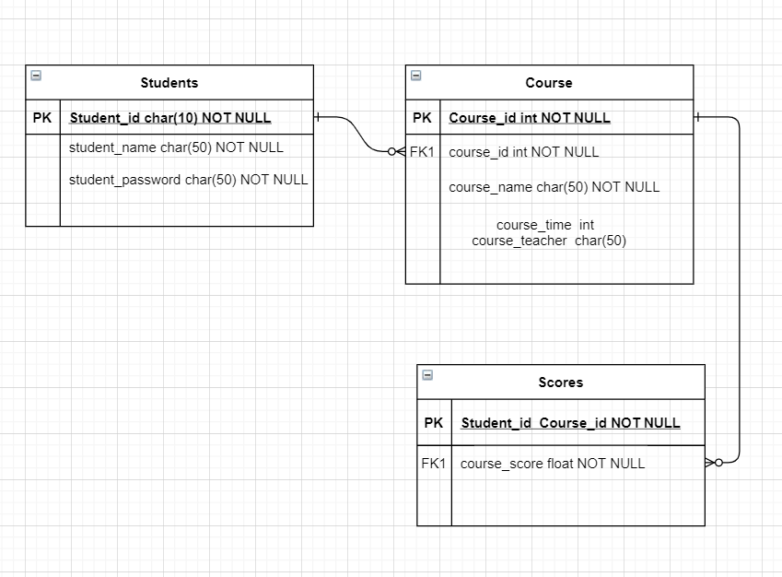

图3-1 数据库ER图

## 2.3 UML类图（Class Diagram）

对于用户功能模块，共设计如下6个类。

* VO实体类User：与数据库结构进行映射的类。主要由属性，setter, getter方法组成，VO类中的属性与表中的字段相对应，每一个VO类的对象都表示表中的每一条记录
* DAO接口IUserDAO：主要定义操作的接口，定义一系列数据库的原子性操作，例如增删改查（通常称为CRUD）等。
* DAO实现类映射文件Mapper：DAO接口的真实实现类，通过配置映射文件，主要完成具体数据库操作，但不负责数据库的打开和关闭。
* 业务逻辑类UserService：对于数据层的原子操作进行整合。还要负责数据库的打开与关闭（不管是否出异常，数据库都要关闭）
* 业务逻辑实现类 UserServiceImpl：实现业务逻辑类的功能，对于数据层的原子操作进行整合。
* Util类：实现一些单独的功能，比如产生验证码图片，对数据进行MD5加密等
* Controller类UserController: 程序的控制器,比如控制登录，退出，课程查询等功能

各类的结构及类之间的关系如图2-5所示：

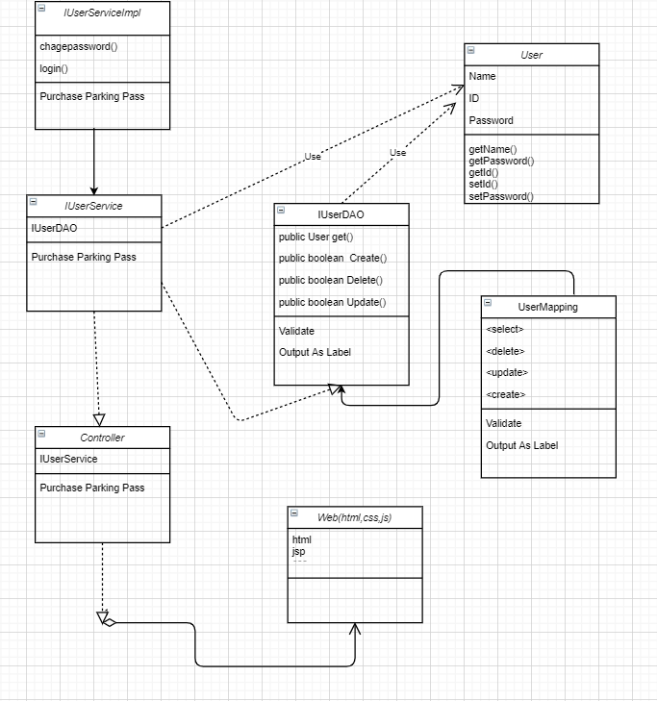

图2-5 用户功能类图

## 2.4 UML时序图（Sequence Diagram）

### 2.4.1 系统登录

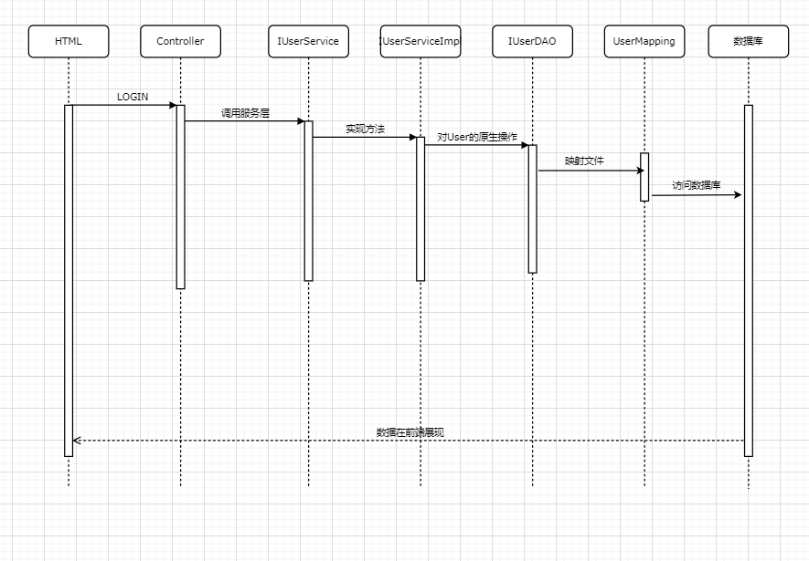

### 2.4.2 课程查询模块

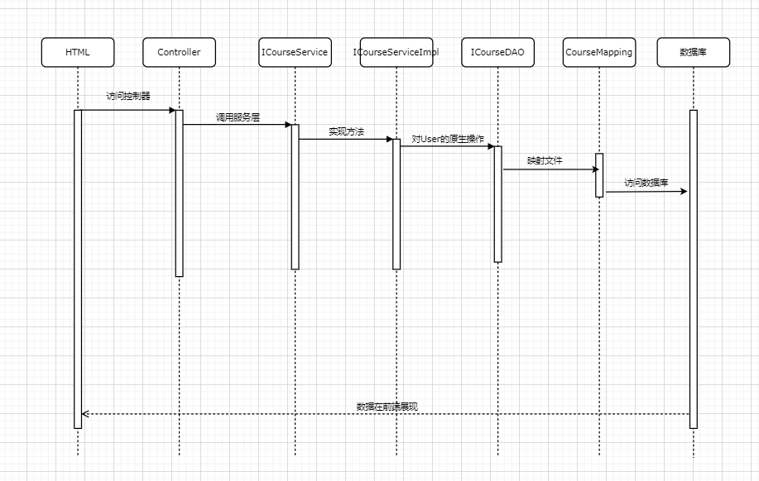

### 2.4.3 修改密码模块

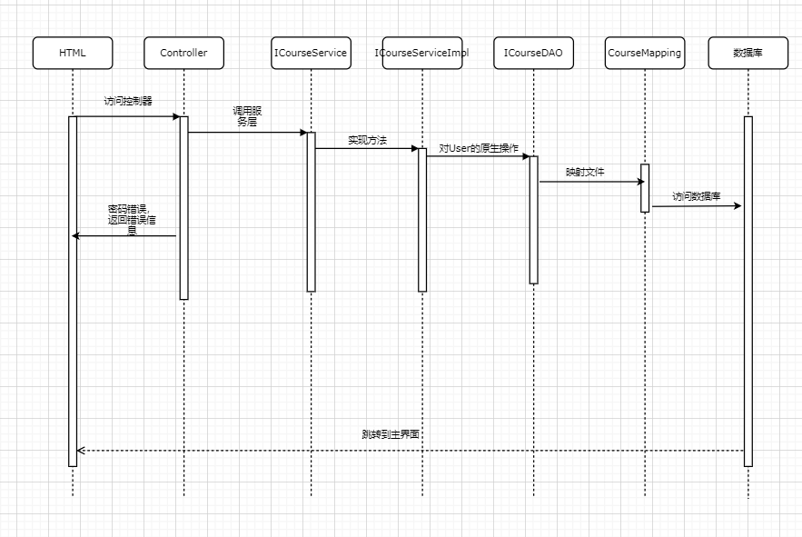

## 2.5活动图

登录操作需要验证用户名，密码，只有当用户名和密码同时存在即用户存在的情况下才能成功登录系统，否则会提示错误信息，具体流程如图2-6所示。

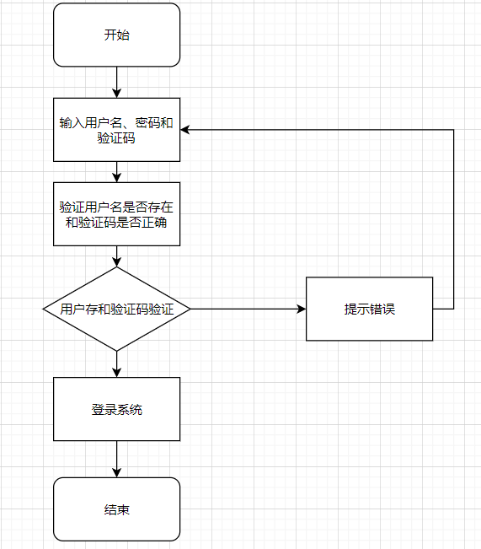

### 2.5.1学生选课界面

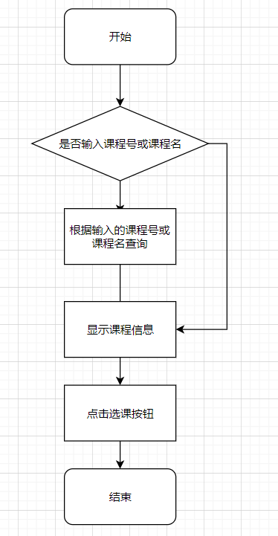

### 2.5.2学生退课课界面

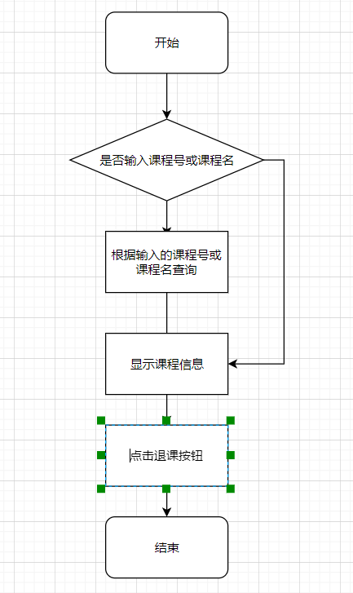

### 2.5.3课表查询界面

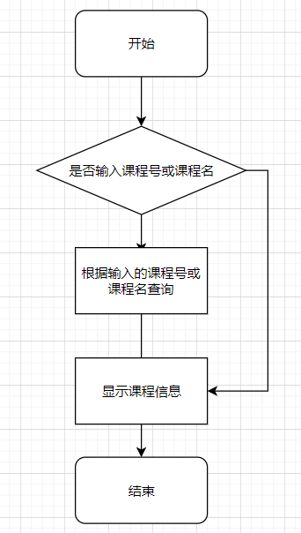

### 2.5.4成绩查询界面

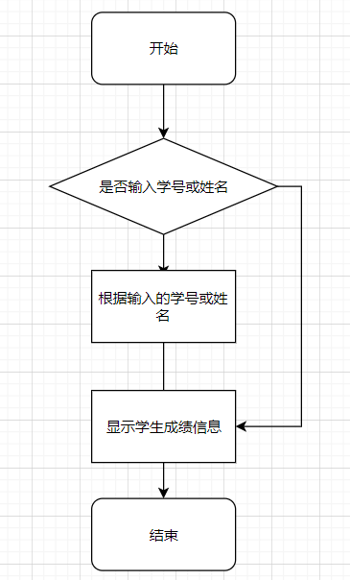

### 2.5.5修改密码界面

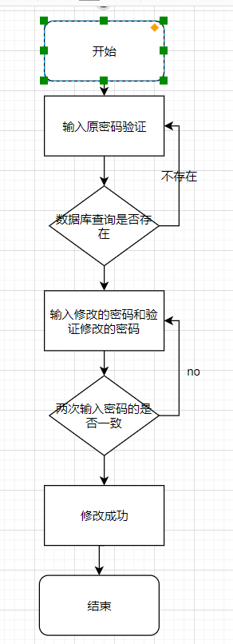

# 3 系统实现

## 3.1 项目结构

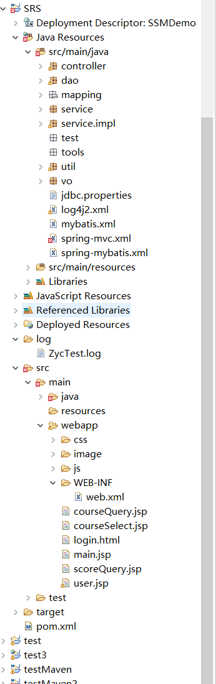

## 3.2 配置文件

### 3.2.1 jdbc.properties文件

该配置文件主要是以文件形式保存数据库的驱动类名称，连接数据库的URL地址，访问数据库的用户名及对应的密码，程序运行时会读取该文件相关信息，避免硬编码，当相关信息发生变化时，只需修改配置文件而不用修改源代码，增加程序的可扩展型。

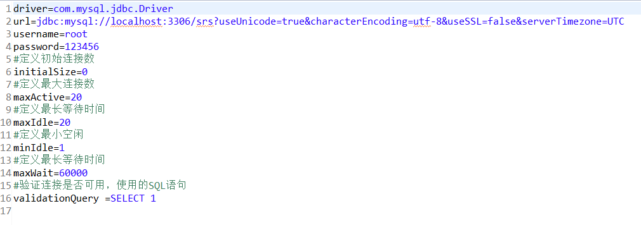

### 3.2.2 log4j.properties文件

描述该文件作用，并对里面的配置进行解释

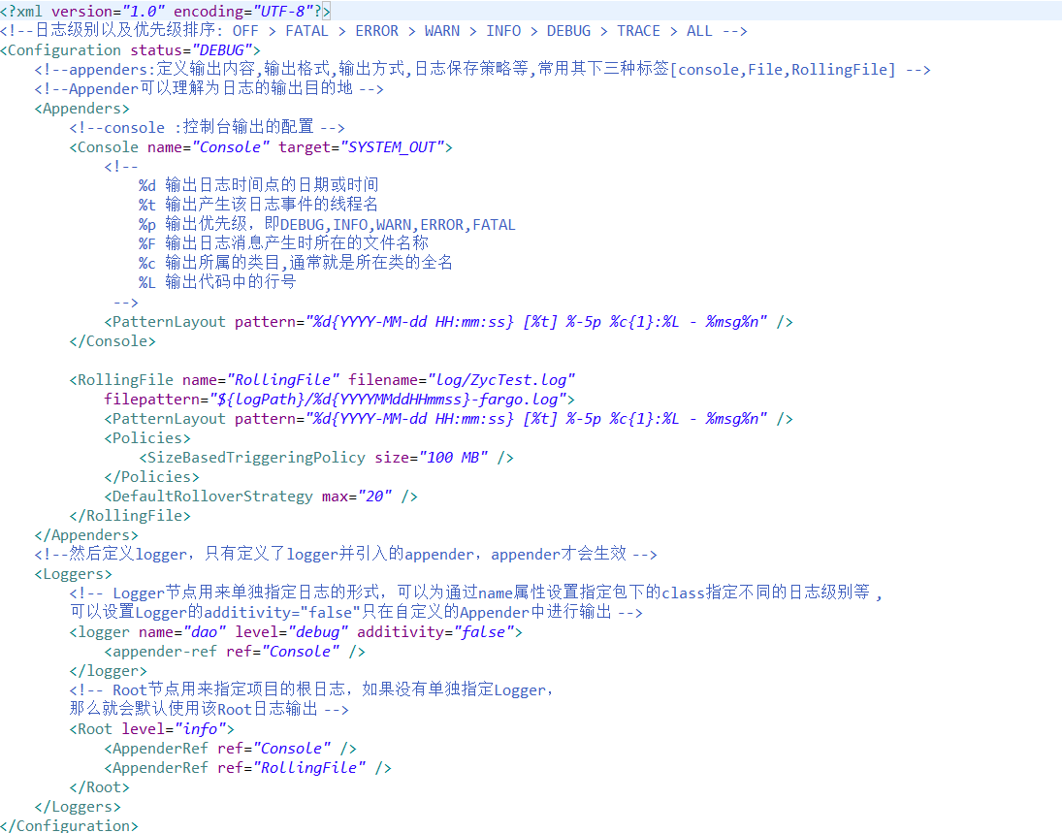

### 3.2.3 mybatis.xml文件

描述该文件作用，并对里面的配置进行解释

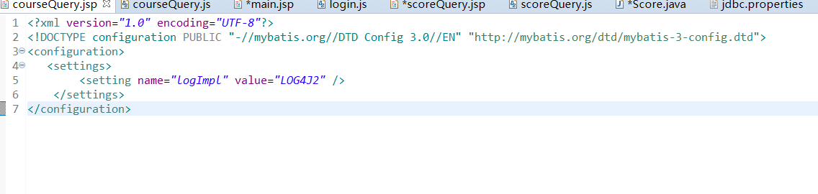

## 3.3 VO类User.java

描述该文件作用，并对里面的关键代码进行解释

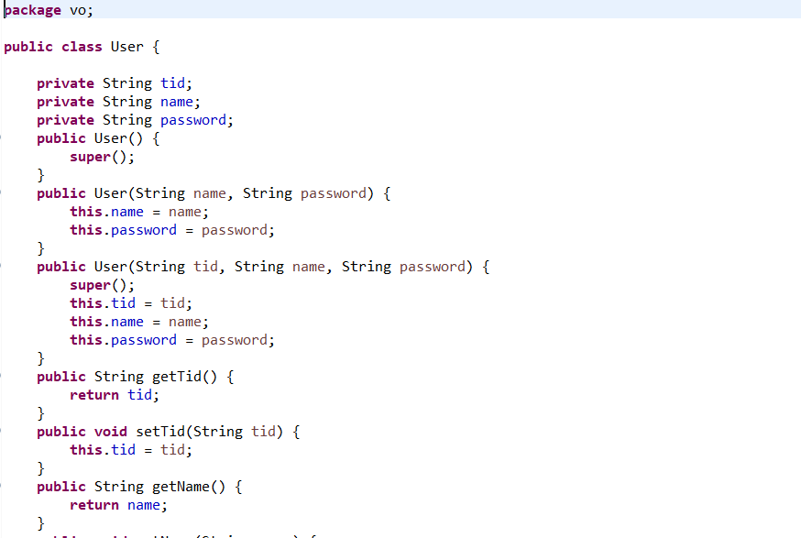

## 3.4 DAO接口类IUserDAO.java

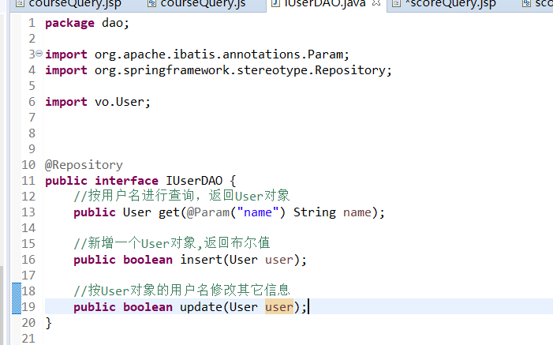

## 3.5 接口映射文件UserMapper.xml

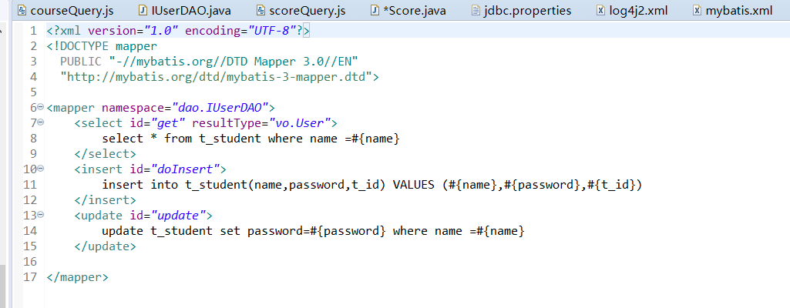

## 3.6 工具包Util

### 3.6.1 CreateImage

产生验证码图片

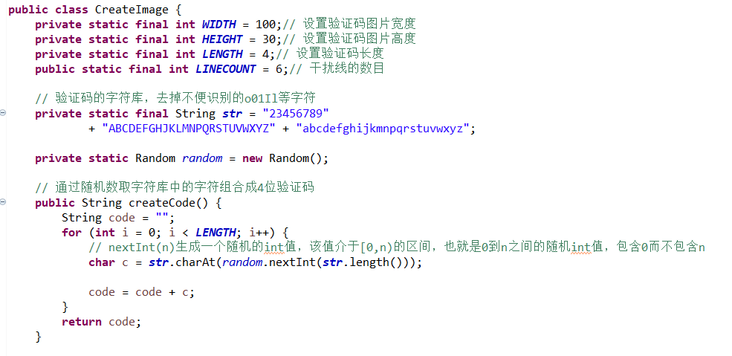

### 3.6.2 MD5Util.java

该类主要实现对数据库中的用户密码进行MD5加密，描述该文件作用，并对里面的关键代码进行解释

**public** **class** MD5Util {

**public** **static** String md5(String str) {

**byte**[] digest = **null**;

**try** {

MessageDigest md5 = MessageDigest.*getInstance*("md5");

digest = md5.digest(str.getBytes("utf-8"));

} **catch** (NoSuchAlgorithmException e) {

e.printStackTrace();

} **catch** (UnsupportedEncodingException e) {

e.printStackTrace();

}

//16是表示转换为16进制数

String md5Str = **new** BigInteger(1, digest).toString(16);

**return** md5Str;

}

**public** **static** **void** main(String[] args) {

System.***out***.println(*md5*("admin"));

}

}

## 3.7 服务层UserService.java

描述该文件作用，并对里面的关键代码进行解释

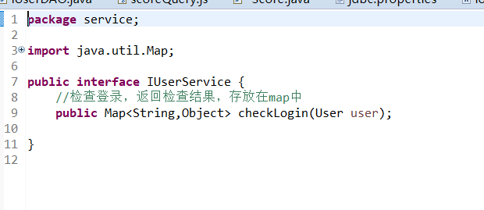

## 3.8 UserServiceImpl.java

描述该文件作用，并对里面的关键代码进行解释

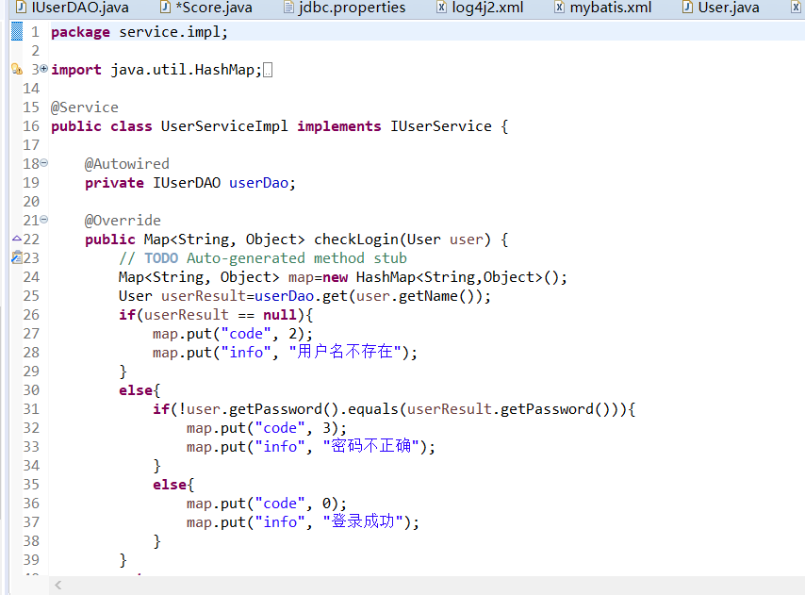

## 3.9 UserController.java

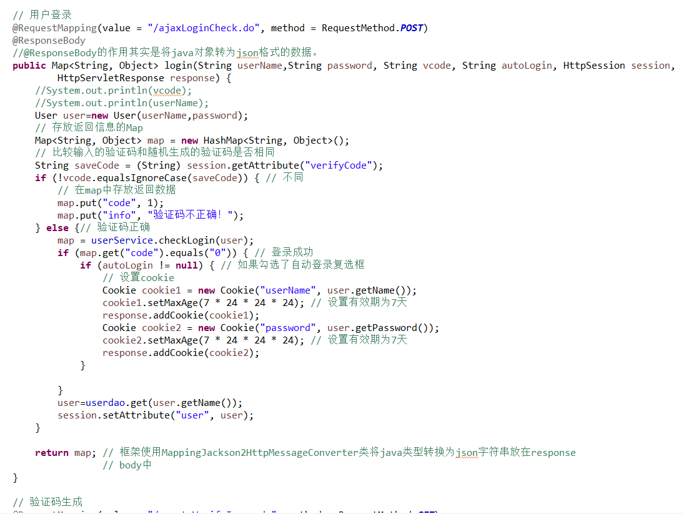

# 4 系统测试

登录

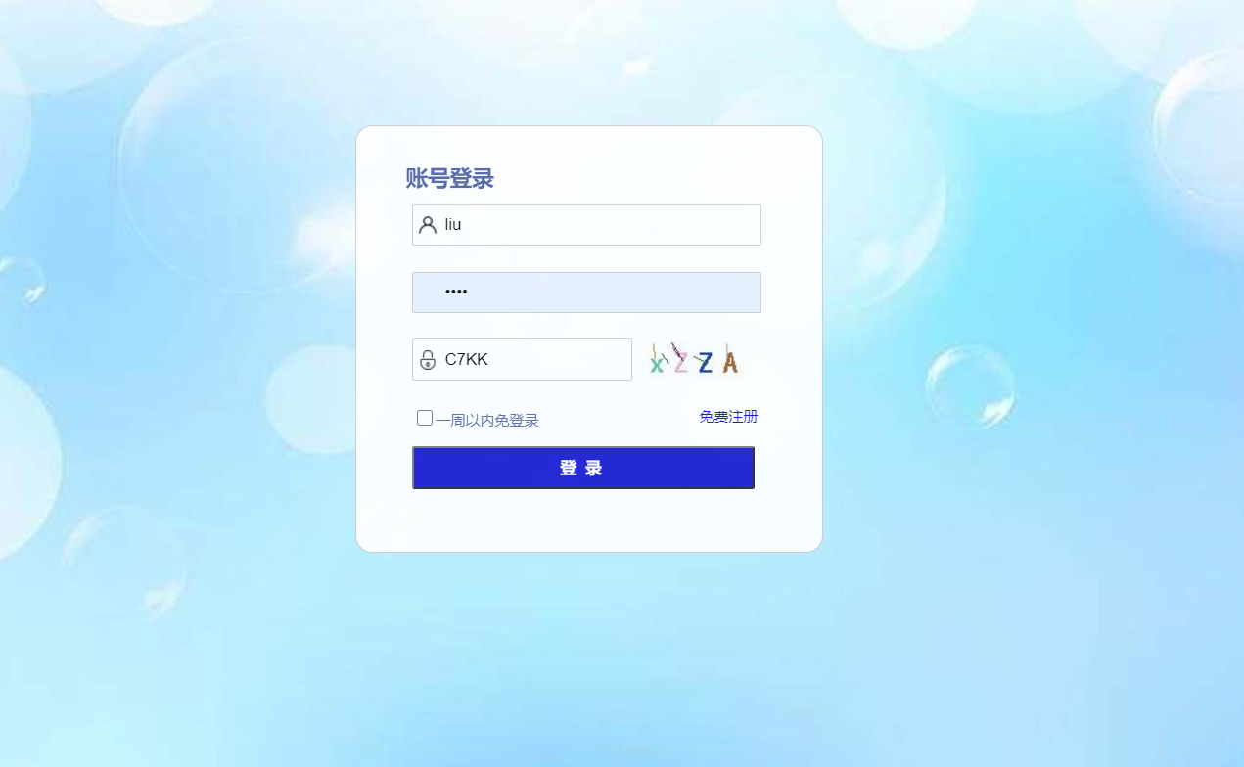

主页面



课程查询

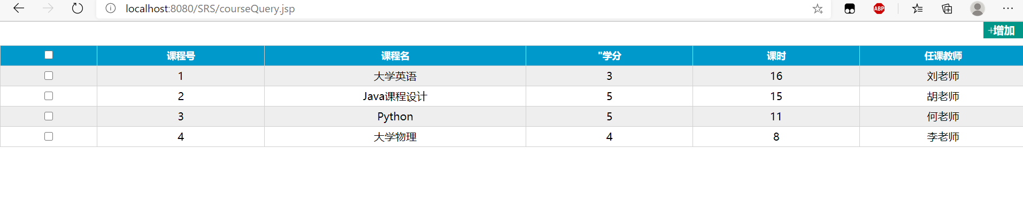

修改密码

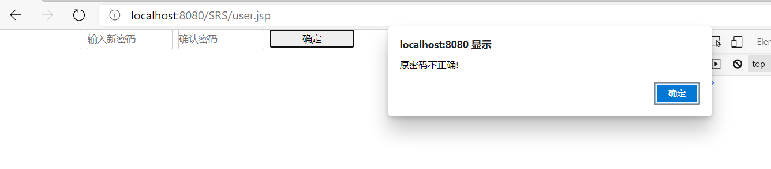

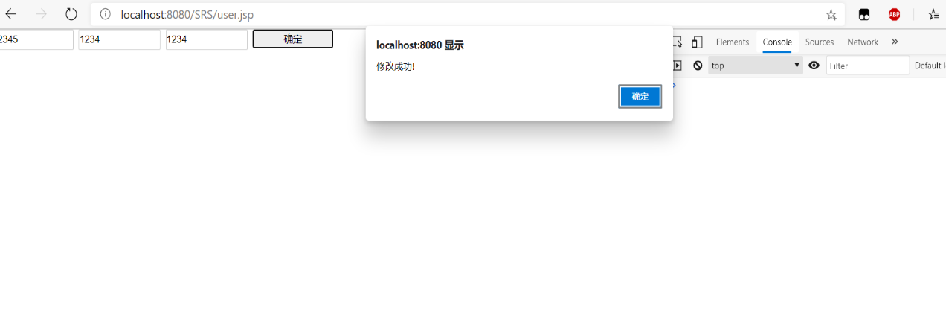

# 5 系统总结

这门课实用性非常强，从前端到后端，前端需要的基础知识html,css,javascript,然后一些框架的使用Ajax，vue，jQuery,boodstrap等，后端本学期主要是mybatis，spring-mvc，SSM框架等，数据库MySQL，服务器tomcat的使用等。如果能够完全掌握，一定能够在社会中有很好的发展，但是这门课需要下很大功夫，需要投入足够的尽力。

我觉得我自己存在的问题就是前端方面的不足，html,css还好，后面的JavaScript就没有掌握的很好，所以界面等方面做的不是很美观，甚至只是应付。在平时学习中都感觉还好，没什么大问题，结果导致最后两天才处理大作业，大意了，只能匆匆应付一下了。

这个课程设计说实话没什么技术含量，就看熟练程度和平时的学习掌握程度了，然后一些细节的地方，**不管平时成绩的话**，我给自己**65-75**分吧，毕竟应付了事了，有些功能没有实现，就增加按钮功能，实现增加删除就可以了。

遇到的问题和平时都差不多，只是一时想不起来重新去解决，很浪费时间，比如映射文件的配置，控制器接收参数，访问数据库错误，界面很丑等等,后面自己再花时间把这个搞好一点，起码得看得过去。

以后的发展方向肯定是计算机的，应该是软件Java，python方向，过年的时候准备考研了，目标院校武汉理工，加油吧，打工人!